MongoDB Assignment D
Haadiya Hasan Faruqi

Database : companyDB
Collection Name : employees
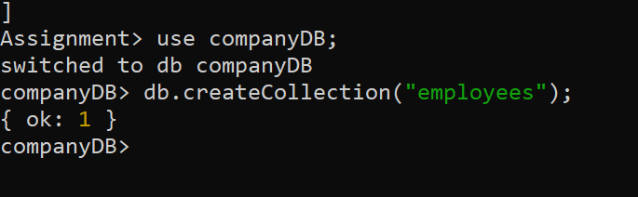

- Display all employees who have MongoDB skill
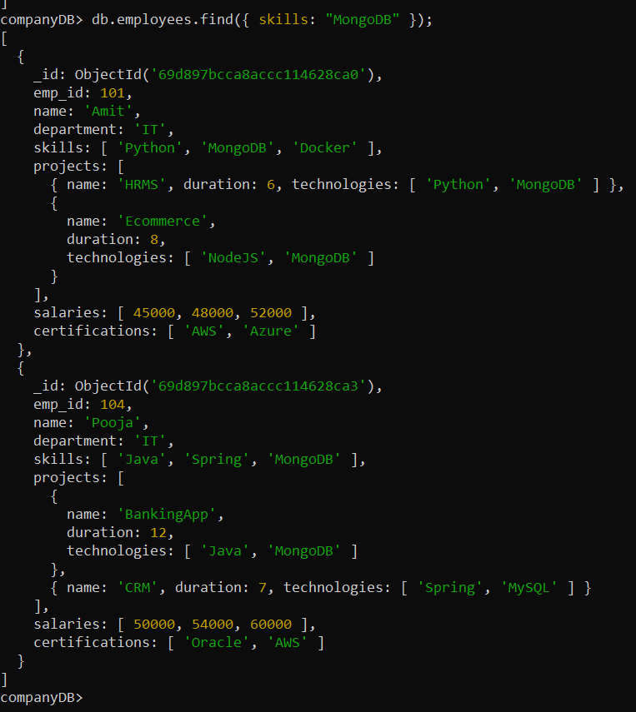

- Find employees having both Python and MongoDB skills
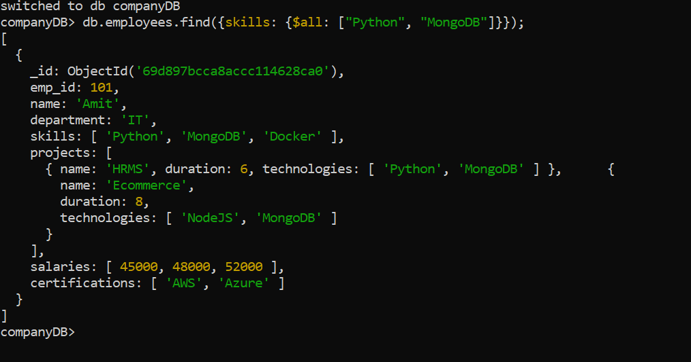

- Display employees with more than 2 skills
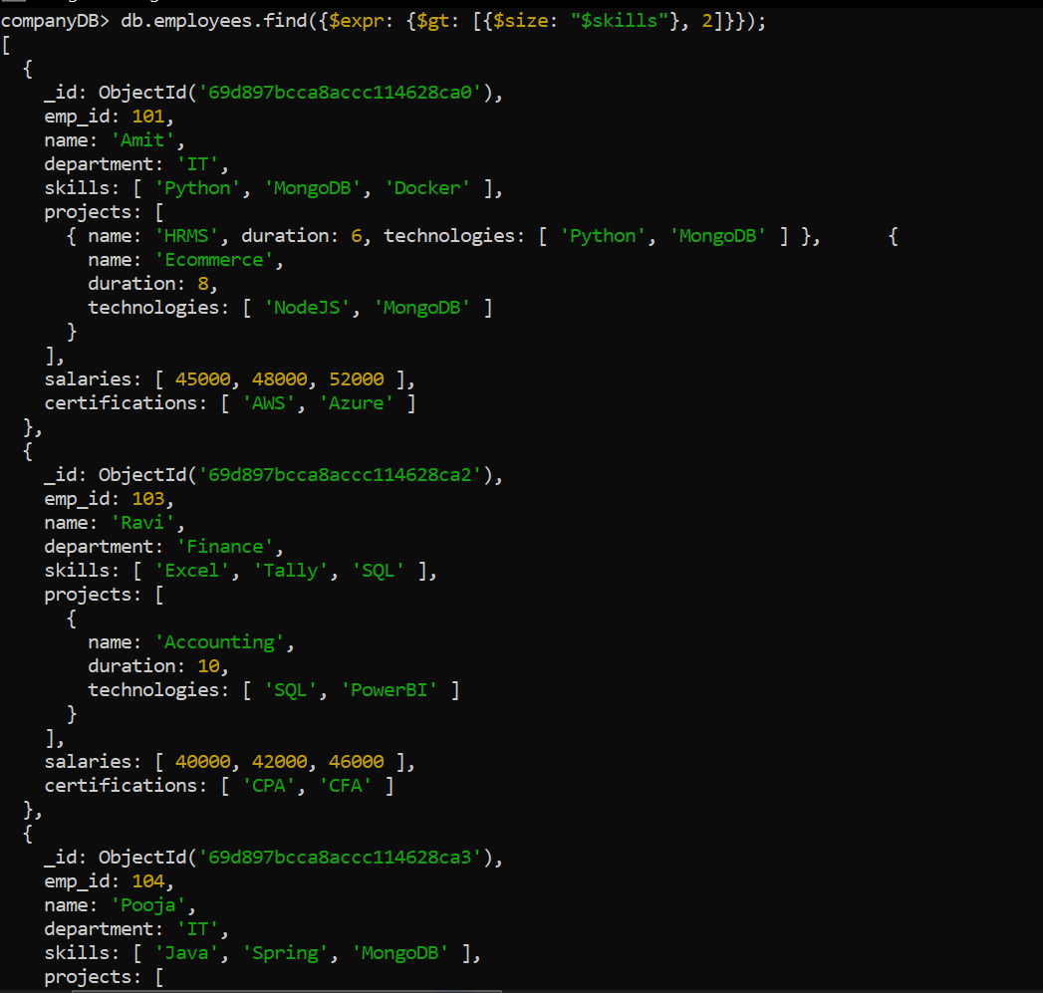
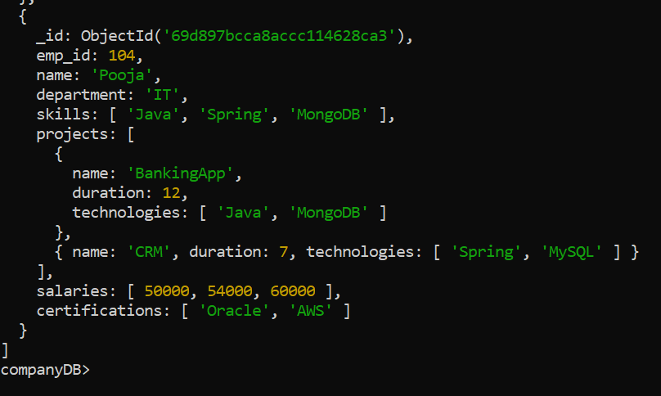

- Add a new skill "Kubernetes" to Amit
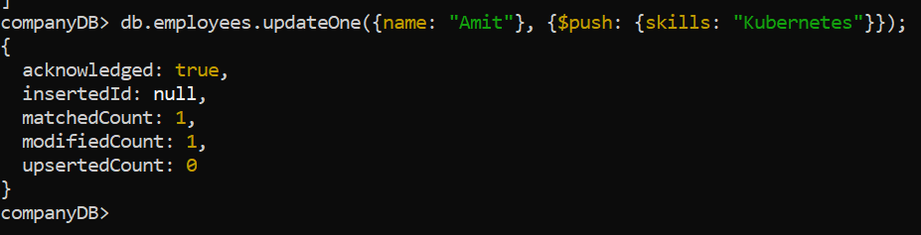

- Add multiple skills to Pooja
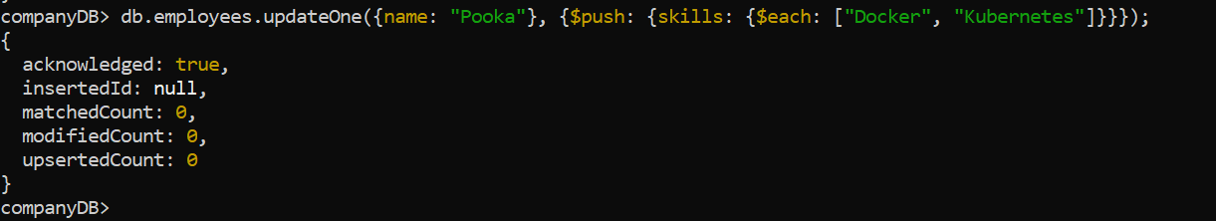

- Add a certification only if not already present
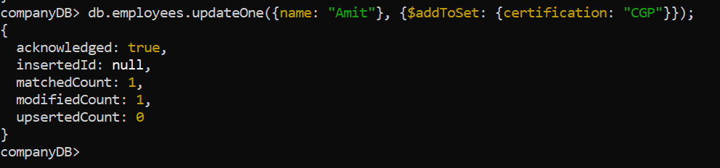

- Remove "Docker" skill from Amit
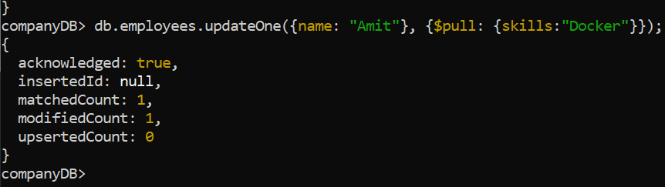

- Remove multiple salaries less than 45000
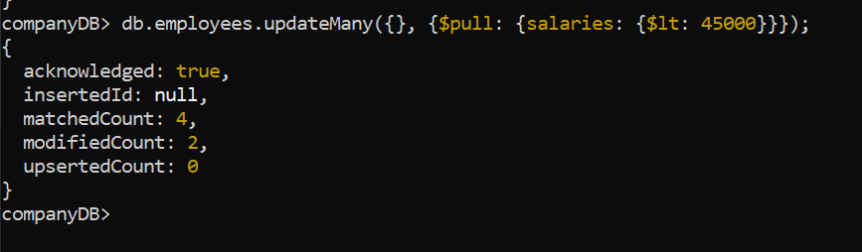

- Find employees who worked on MongoDB projects
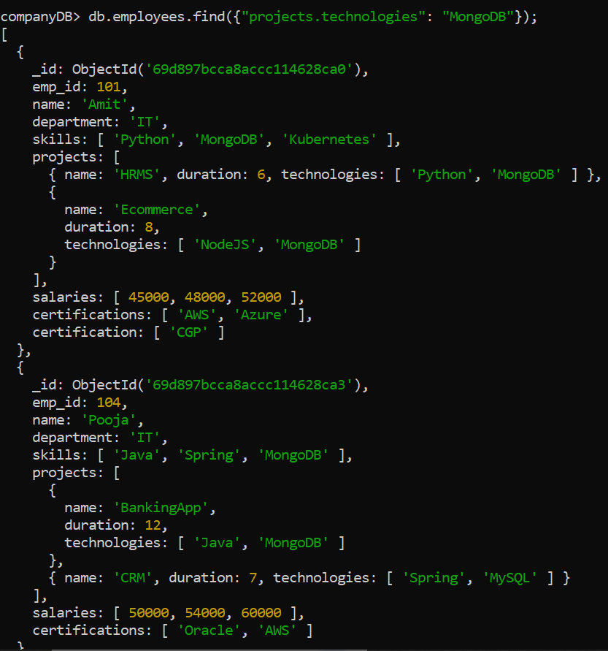

- Use $elemMatch to find project duration > 6 using MongoDB
-> Topic not Covered

- Count number of projects for each employee
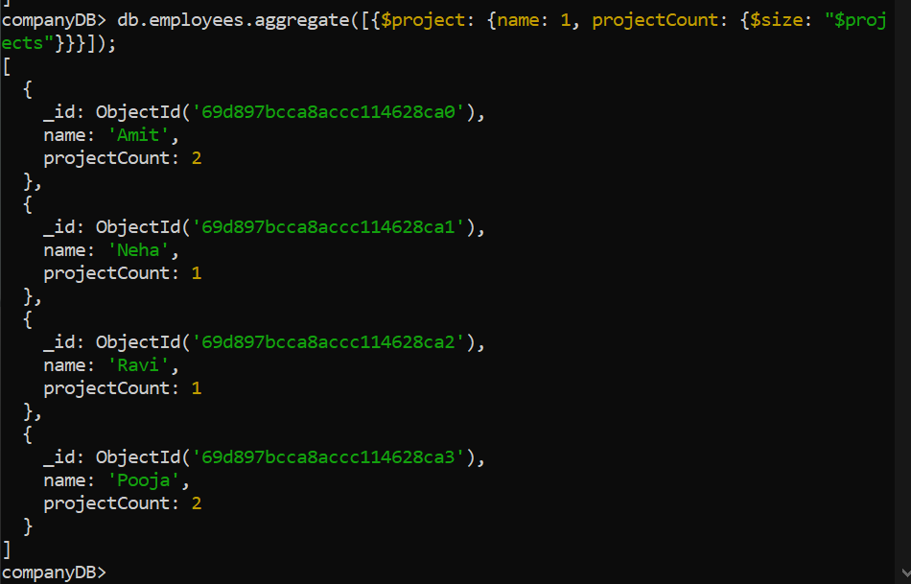

- Unwind skills array
-> Topic not Covered
- List unique skills across company
-> Topic not Covered
- Find employees with salary greater than 50000
-> Topic not Covered
- Find employees with exactly 2 certifications
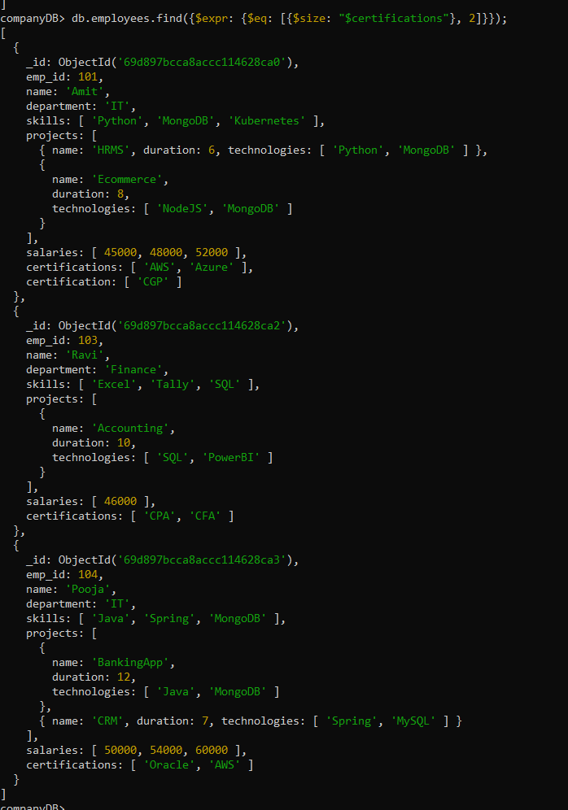

- Add new project to Ravi
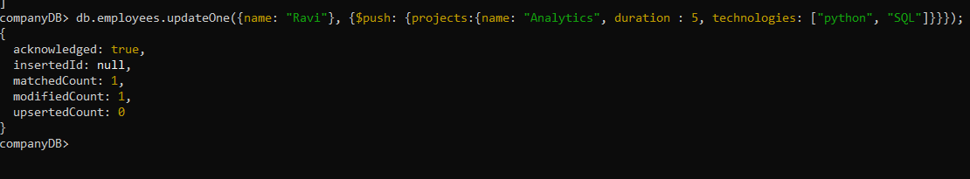
- Increase all salaries by 10% (array update)
-> Topic not Covered

- Find highest salary of each employee
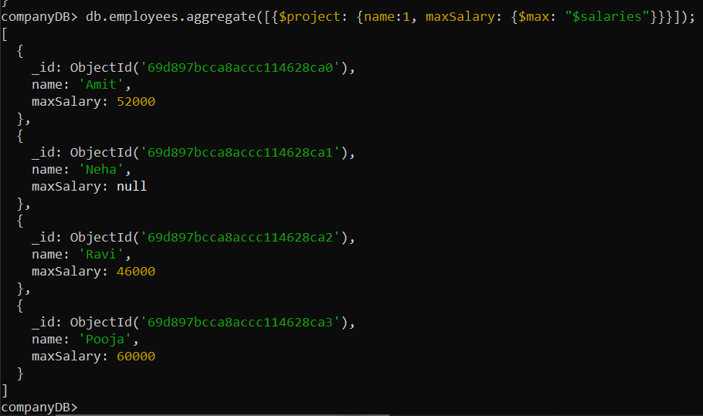

- Find average salary of employees
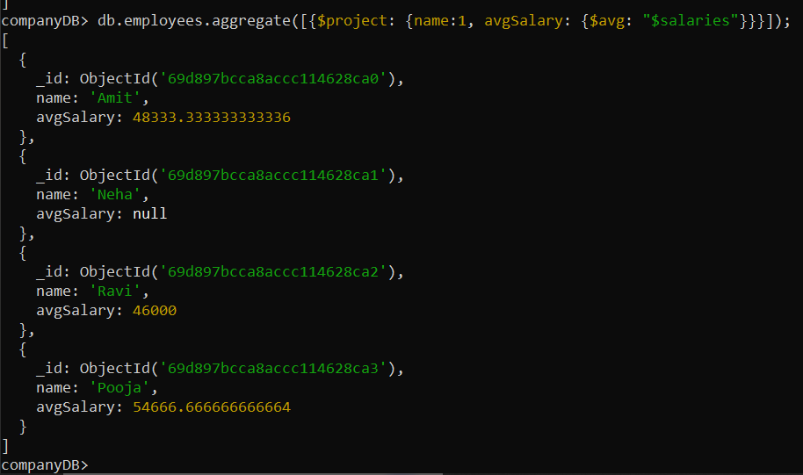

- Filter projects longer than 6 months
-> Topic not Covered
- Find employees who have any of these skills: Java or Python
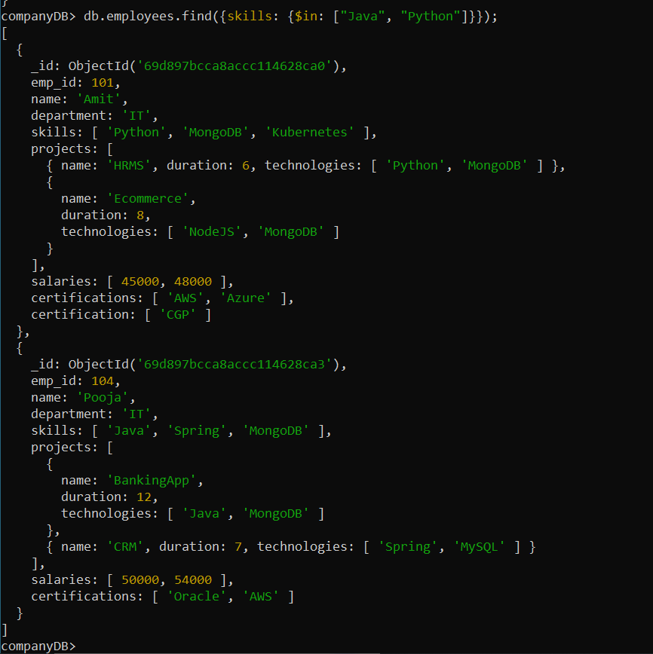
- Remove last salary entry
